Task 9

Here I use data 1000 rows from my source. We see that I have data 995 rows for all period (I have about half year data).
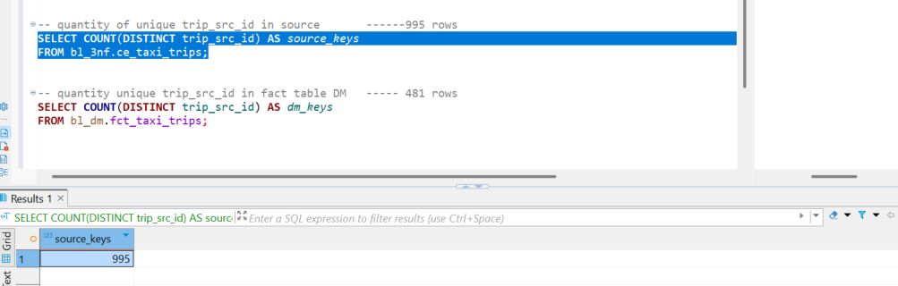
And 321 rows for 2 month … so yeah partition it is working

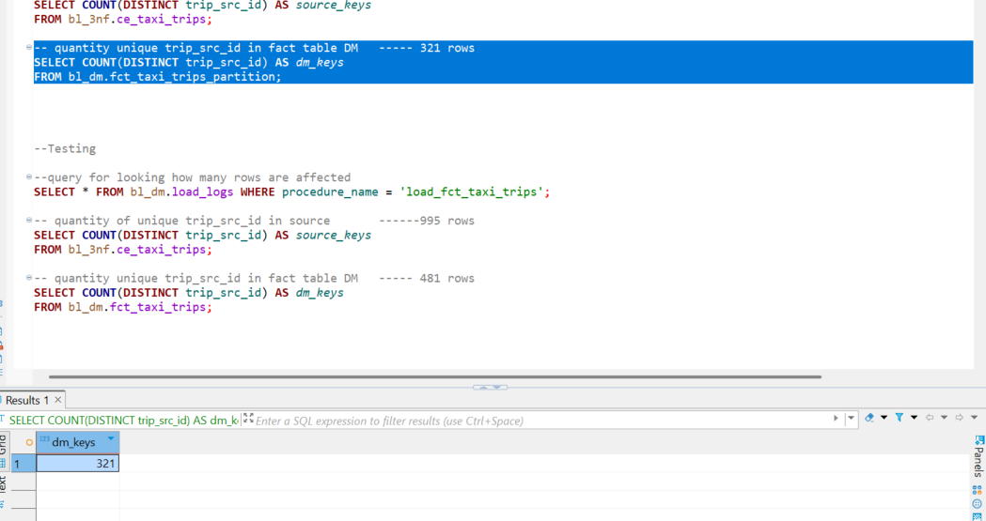

Log
we see that log is same, row affected 321 …and when I one more time execute procedure it is 0 rows affected 😊

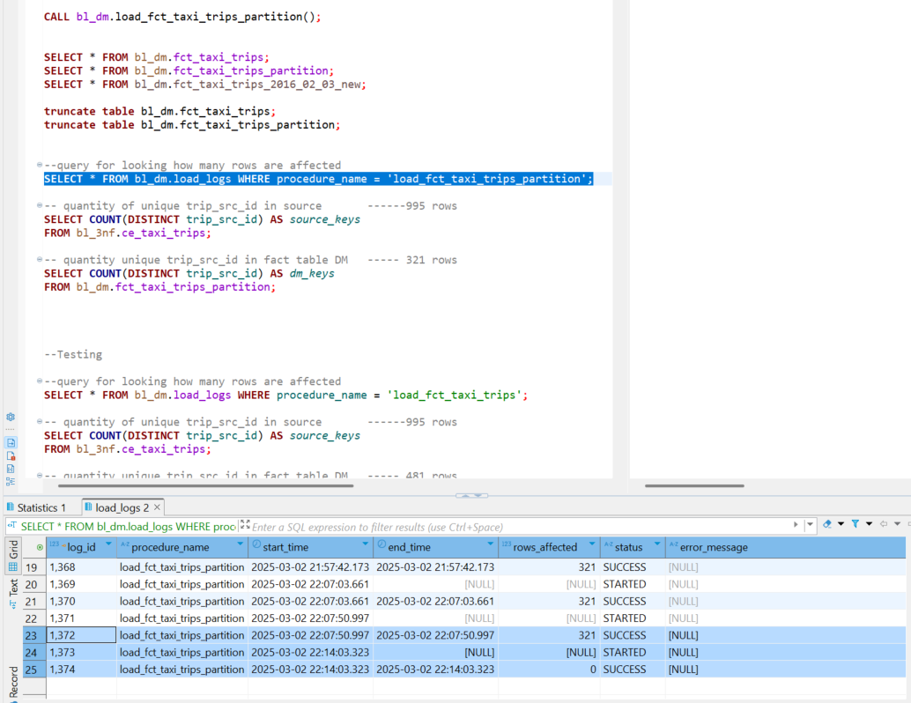

So when I made partition of fct_taxi_trips table … child table 321 rows. Parental table show all rows in all child partition. And child partition shows only rows are in child table.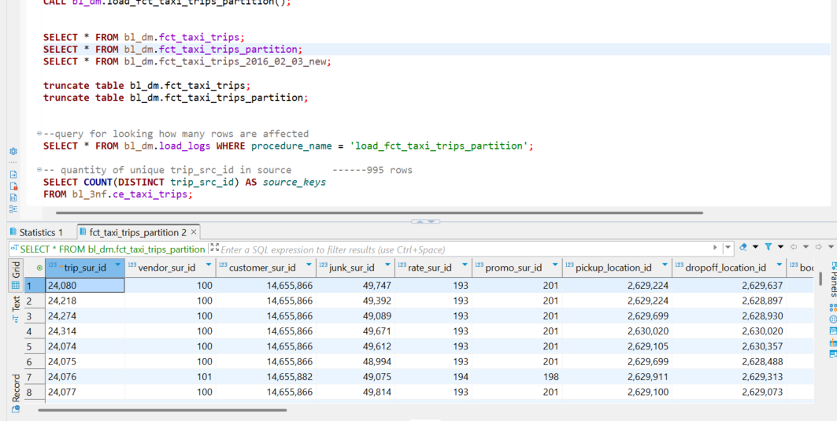

So I am understand that my code is not so good, because we don’t need to update rows if no data changes 😊

With pre fact table ce_taxi_trips I have working code with full and incremental loads

Full load
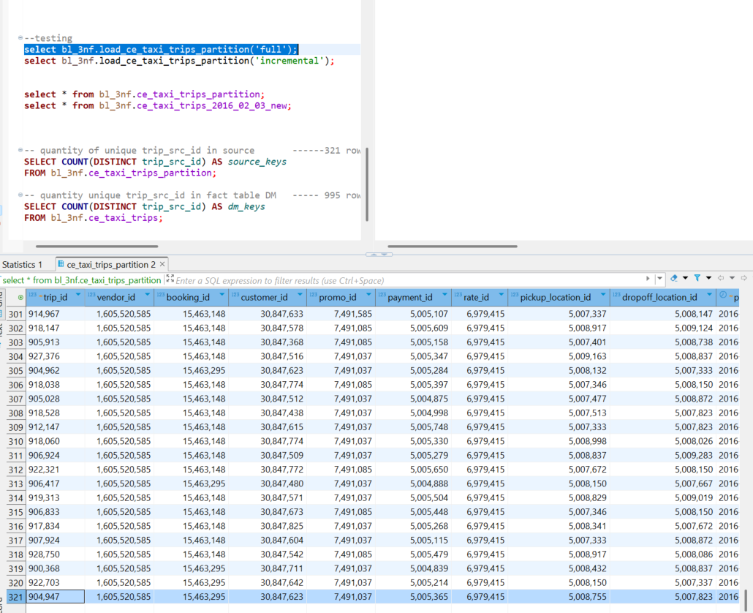

Incremental load when I add row
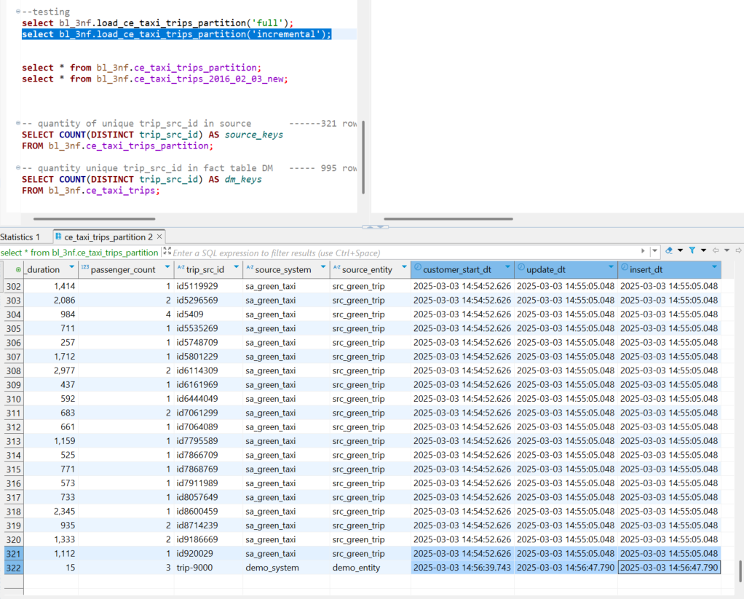

Incremental load when I change row